HARSH REALITY

DESIGN DOCUMENT

# Harsh Reality

After a long run, defeating bosses, the game may give you hope when you get a new item or resource meaning for you run, for your life.

The purpose of this is to give you hope. Within the momentaneous hope you have at the present exact moment, break it with a harsh reality and enemies willing to **really kill you**.

If you be able to

You know the things said are true, and may be true. But you must decide what you want to do, ignore it and act as it doesn’t exists or accept it and keep fighting.

Either way, it wont change what still happening to you, it may change how you will deal with the outcome and things that will keep happening to you. Because as you already know at this point, they will never stop to exist. Bad things will always exist as good does.

## Harsh Reality - Phrases Examples

You were too kind, so

The world has become meaner

You were hopeful, so

The world showed his face, again

You had a beautiful life, so

They will try to take it back

You've come so far, so

They will certify it won’t be worthy

You’ve become so strong, so

They will show your weakness

You've got many friends, so

Now you may lose all of them

You've discovered a lot of new things, so

They will make you take it to the grave

You've got so far, so

Now you will have to do everything once again

You already know what will happen now

Suffering is unavoidable

Nothing lasts forever

As your born and existence will do

The universe is not at your side, because

Its not a living thing

There's no entity or spiritual energy that will help you

You are by yourself

This world is cruel and

Accepting it or not, it’s not your option

You are feeling alone, and

You will feel it again until you die

You feel powerless

Because you really are

Everyone has their problems

You are nothing special

Your soul and your body are in the physical world

As you just came to the world, you will go

As life was gifted to you when you were born

It will be taken from you when you die, you are not eternal

The world is unfair

Because it wasn’t made for us

The universe is not at your side, because

Its not a living thing

There's no entity or spiritual energy that will help you

You must to solve all your problems

This world is cruel and

Accepting or not, it’s not up to you

These people are evil

You will find worse

You’ve got what you deserved

Now deal with it

# Real Killing Will

Real will to kill is one of the base states of the game. In this state, the entity will do anything to kill its enemies and overcome its objectives.

In this state the entity show its real face and become meaner, stronger than can ever be, faster than can ever be, brutal than can ever be.

# Pure Evil

Pure evil is one of the base states on the game.

# Negative Attributes

Negative attributes always come from positive attributes, meaning that loneliness for example may follow for the fact you always have friends.

They are never good, and the intention is to make you feel bad.

# Story

# Overview

Skill Impact would be a game where the focus would be battles between two combatants, or one combatant to more.

## Main User Experience Objective

The user experience would mainly rely how the skills are affected when hit a shield, when hit a combatant with armor.

The more aggressivity and killing will, the better user will be rewarded.

## The Game Must Be Close To Real Life

The game would mainly rely in how things would behave in real life, even with powers, they must beave how actually it would in real life.

Including damage, in a world where powers exist, people would behave how they would if around powers in real life. The safety rules would need to change, health care rules would need to change.

## Inflicting and Receiving Damage Behavior

As when you can kill somebody by crushing their head in real life, in the game that would be an instant killer too, everybody is human, everybody suffers the same in this game, the only thing that most matters are to keep alive, and to survive.

Permanent damage also exists, if you break a leg, you must fix it if you can fix it, if you can’t it won’t bring to its original form. There would be power that could help you to regenerate or make pain less, but as medicine, everything has their own limitations, this world has its own limitations as real life.

# Concept Art

# Reference Examples

## Momodora

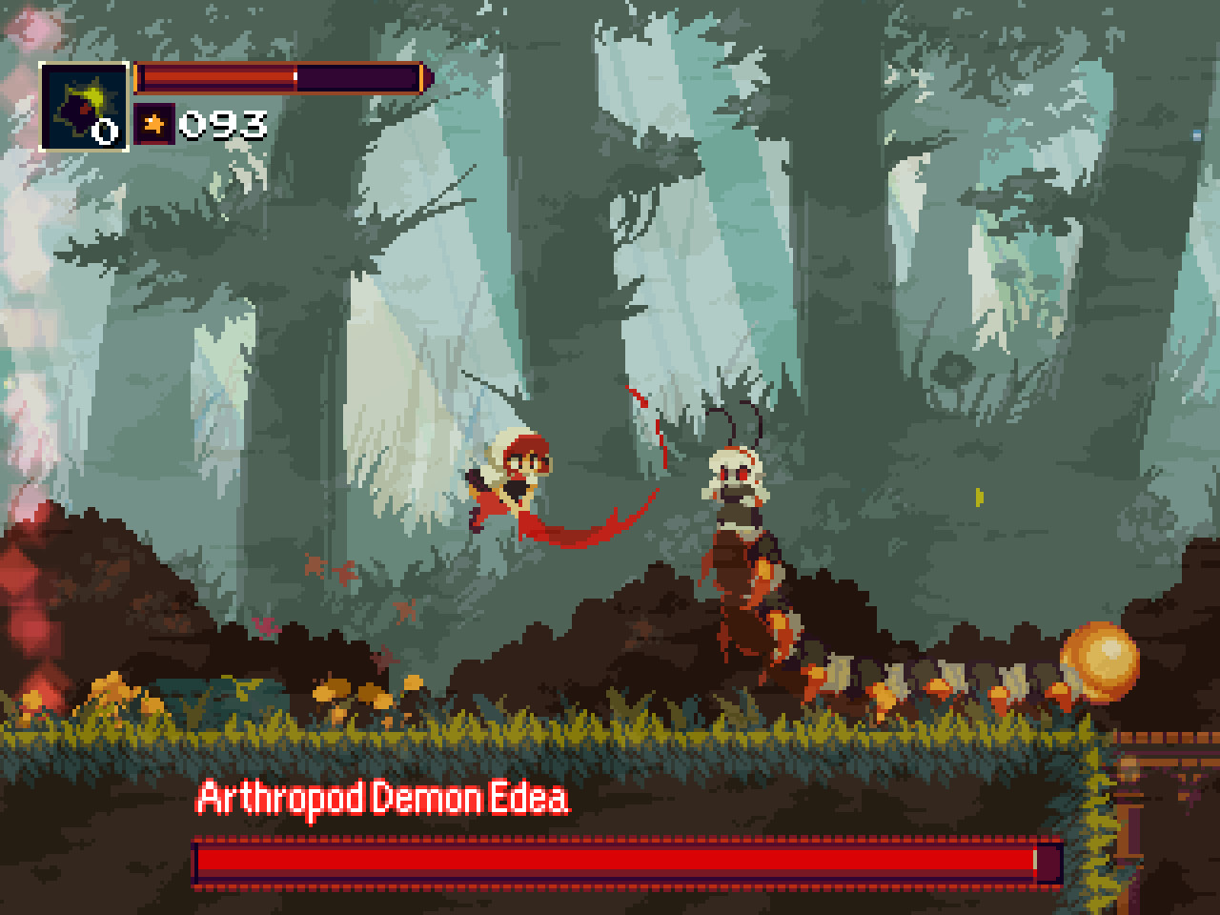

1Momodora: Reverie Under The Moonlight

## Riot Games

### Yasuo

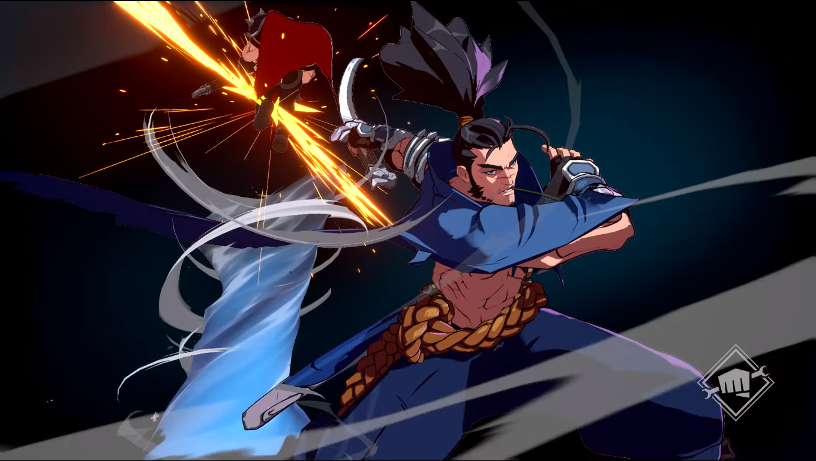

### Riven

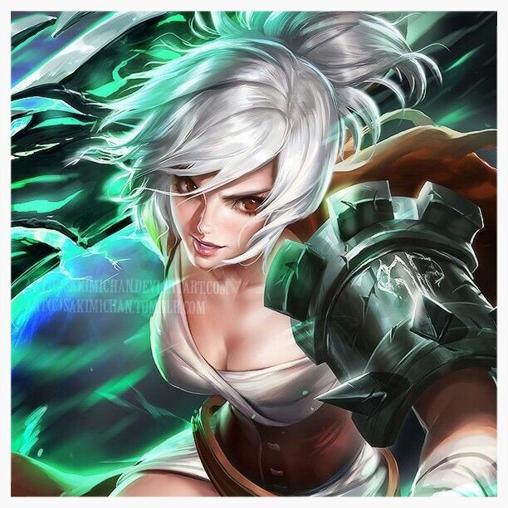

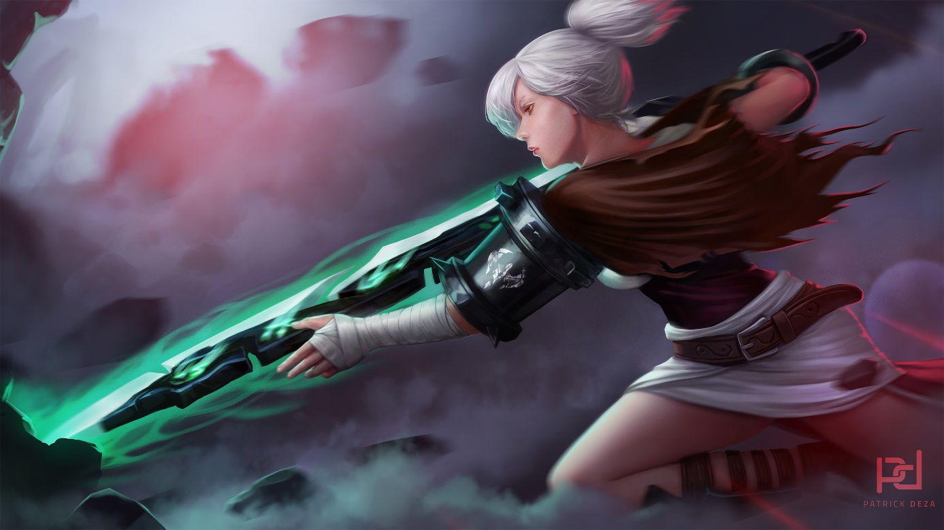

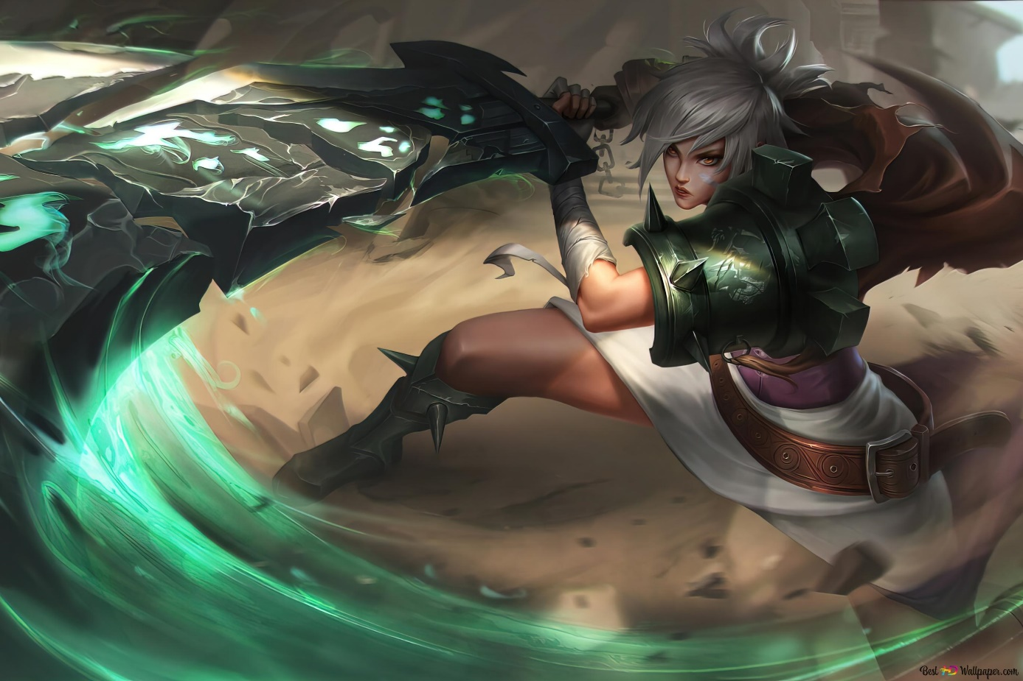

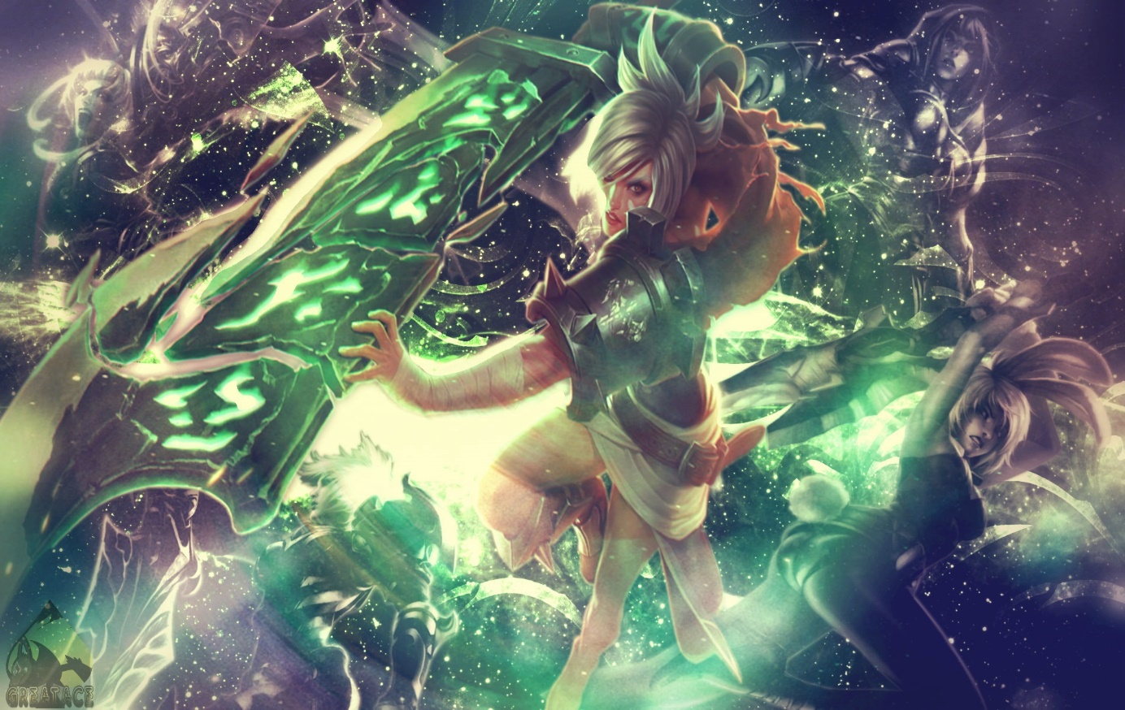

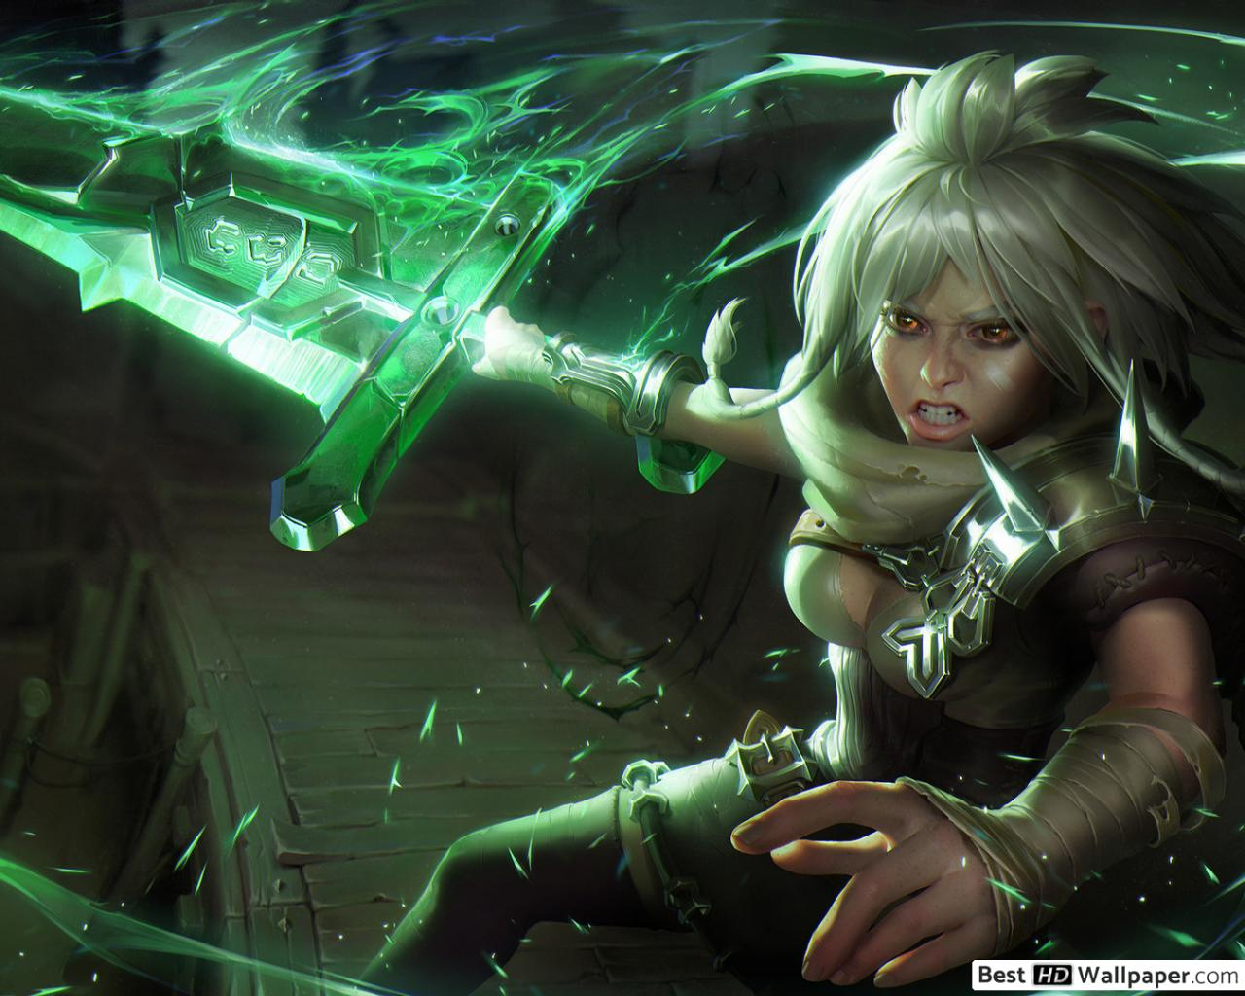

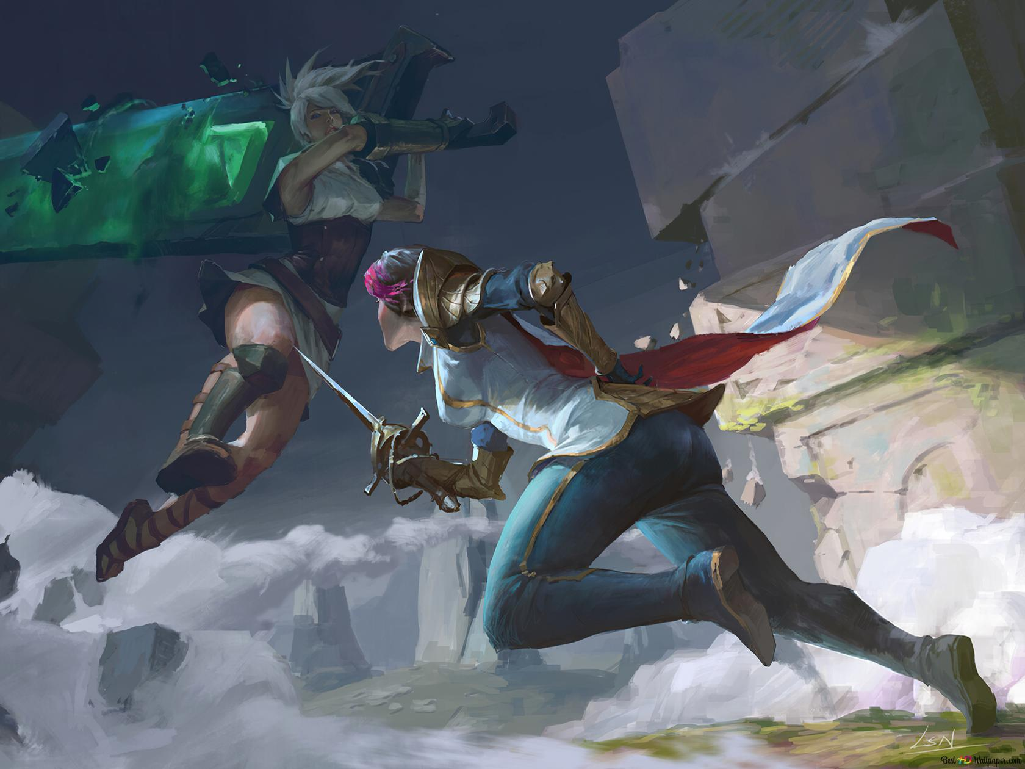

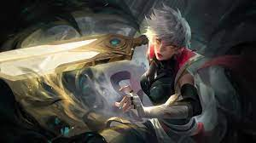

### Jett

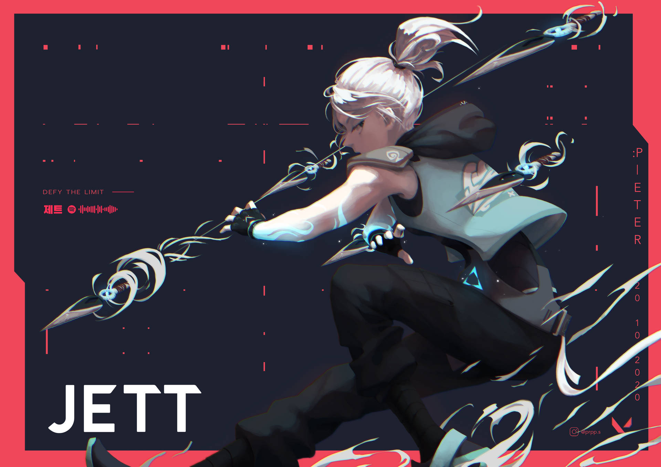

## Undertale

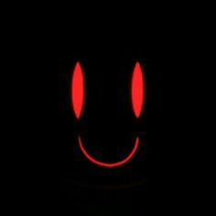

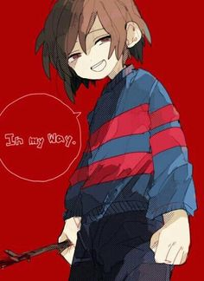

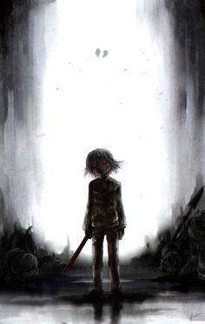

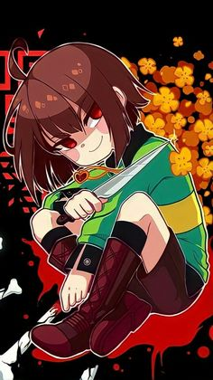

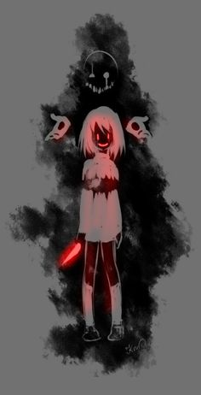

## Gears of War

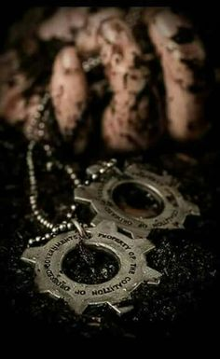

## The Binding of Isaac

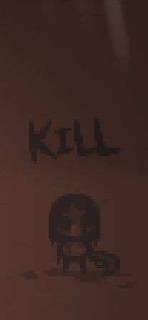

‘

# Project Requirements

|  |  |
| --- | --- |
| Battle System | Battle system would be a bit like momodora. |
| User Interface (UI) | 1. Main Menu with “Start”, “Settings” and “Exit” buttons    1. Settings       1. Audio Control |